**DMIS Honours**

**MAD(A)**

**Personal Reflection**

2147105s

[GitHub Pages URL](https://markstrathie.github.io/)

Creating a fully functioning website without the use of a web framework is a daunting task. It involves many hours of design considerations, writing swathes of various computer code, and searching or creating various content to fill its pages. I undertook this challenging yet rewarding journey that allowed me to delve into the various web development areas of narrative, design, multimedia, and coding. While I made some mistake along the way, it was overall an enjoyable experience. At the project’s end I produced a portfolio website that showcases the skills I gained and touches on my passion for data analysis and artificial intelligence (AI), see figure 1.

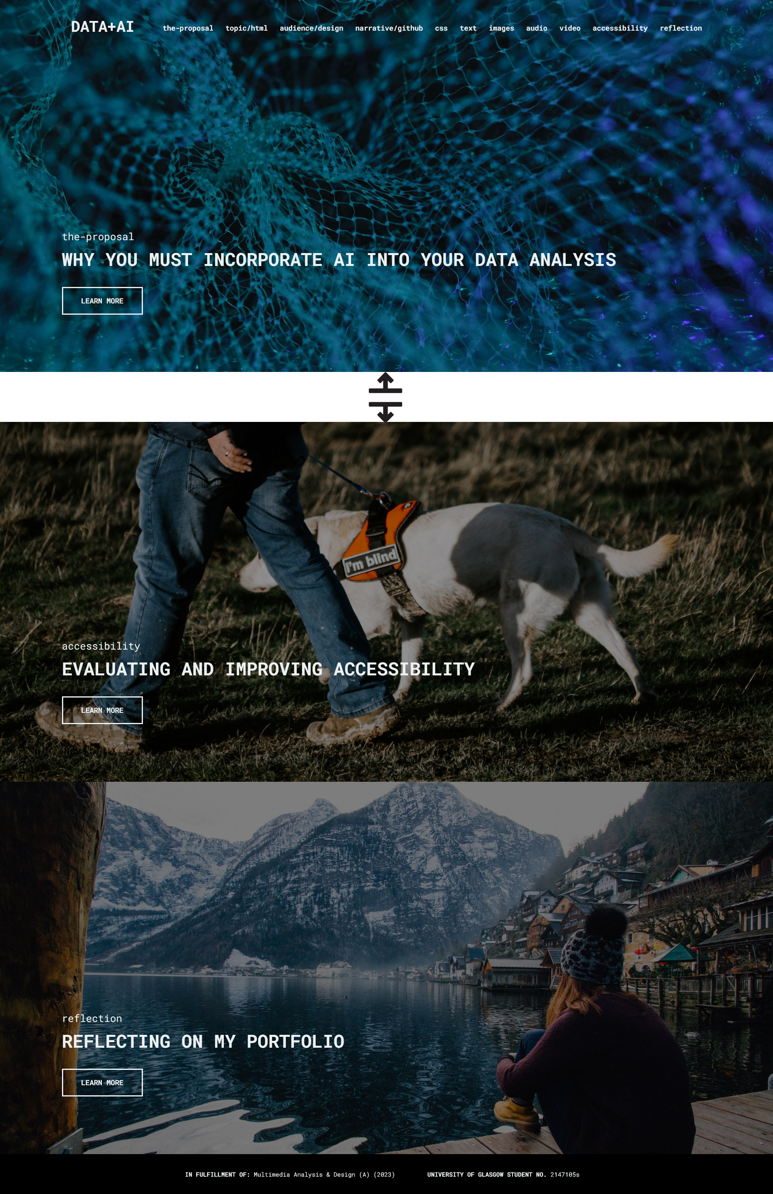

Figure 1. Two sections (start and end) of the homepage of my completed portfolio website.

This personal reflection will explore my experience in chronological order starting with web design fundamentals before progressing on to more advanced skills. I will first reflect on my selection of the topic ‘Why you must incorporate AI into your Data Analysis,’ and then move on to HyperText Markup Language (HTML), audience selection, design ideas, narrative selection, Cascading Style Sheets (CSS), text, images, audio, video, accessibility, and finally JavaScript (JS). Brief descriptions will be given for context, and my thoughts, feelings, and key learning points will be discussed throughout in order to show how the project will inform my future design practise during my degree and beyond.

Selecting a topic was the most challenging part of this project. I have an interest in many different areas of the technology industry which lead to me feeling overwhelmed for the first two weeks. I began investigating high-level sources – news articles and YouTube videos. *Data Scientist: The Sexiest Job of the 21st Century* highlighted to me the increasing demand of skilled data analysts.[1] *Will ChatGPT Put Data Analysts Out Of Work?* also helped me overcome my decision paralysis and identify the area I was most interested in – AI.[2] I then studied the more in-depth journal articles *Human-AI Collaboration in Data Science: Exploring Data Scientists* and *15 Challenges for AI: Or what AI (Currently) can’t do.[3]* These sources reinforced by choice by examining how AI is exponentially popular in contemporary industry and how it is rapidly transforming workflows. I chose AI for this reason as I believe this topic will attract a large audience and provide valuable content. However, it is a broad subject, and I immediately realised I needed to narrow the focus even further. As data science was my second biggest interest, I decided to merge the two together, making my portfolio proposal *‘*Why you must incorporate AI into your Data Analysis*.’*

Simultaneously, to give myself a break from topic selection during the first three weeks, I worked on my portfolio’s HTML. HTML is the backbone of web development and forms the skeleton on which you add your content. While I found this the easiest part of the project due to my previous experience, it was still fascinating to witness how simple code could transform my text into a cohesive web page. This helped my productivity when I needed a rest from researching topics.

Defining the target audience was an integral aspect of creating my portfolio website as I understood the audience will shape the design and narrative going forward. I was excited to utilise the methods of audience personas, user stories, and the laddering interview technique to focus my thinking process. In the end I decided to target my peer group – honours students and young professionals with an interest in the technology industry. I believe they will be the most likely to engage with my website and it will allow me to create content at a level of technical detail I am comfortable with, leading to higher quality production. As a starting point for the design of my portfolio I analysed existing websites which helped reinforce design concepts such as whitespace and use of colour and multimedia. I immediately knew I wanted my portfolio website to be sleek and minimalistic, similar to the technology company Apple. I knew this would give my website a professional and authoritative quality that helps reinforce the validity of its content. I considered my audience when defining a narrative and based it around the *AI Hierarchy of Needs*, figure 2.[4] I was relieved when I discovered this source as I knew it would be ideal to use for my final website’s story. It shows the journey of data and breaks the workflow up into logical sections, allowing me to highlight important steps to my audience in a sequential order.

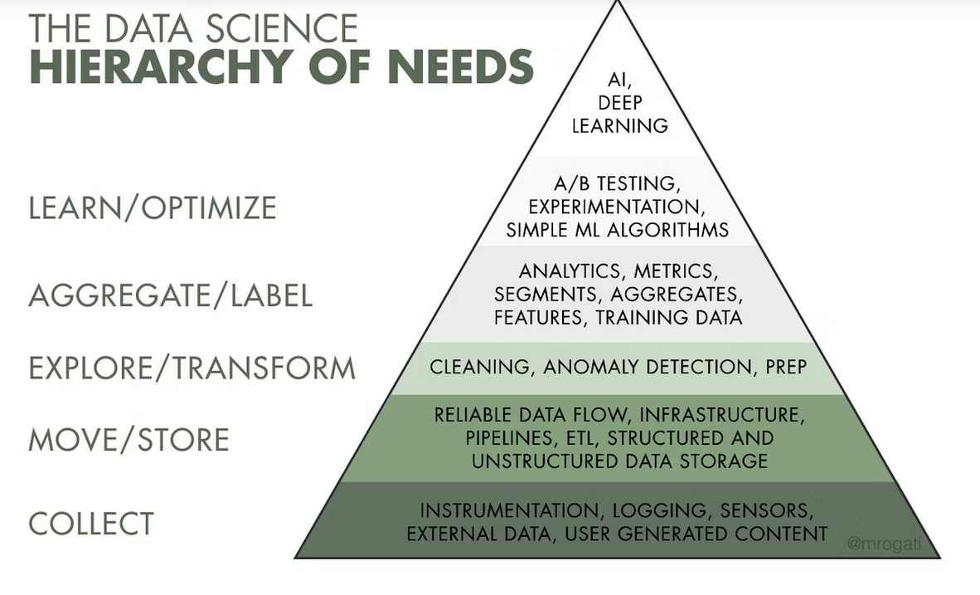

Figure 2. Monica Rogati’s AI Hierarchy of Needs, the base of my narrative.

CSS is code that adds visual styles to websites – fonts, colours and layouts to manipulate the content. I spent the majority of my project learning how to write CSS and while this was not the most efficient method, it was the most rewarding for me. At the beginning of my project, my portfolio consisted of basic black backgrounds with unformatted text and images all aligned down the left of the screen in a confusing wall of information. I felt embarrassed to host a website that looked like this. Websites that fail to use CSS are almost non-existent on the contemporary web. I knew users would not engage with a website like this as it is difficult to read and lacks any inspiring design. See figure 3. I was motived to learn CSS to a high standard as without it I believed I would be unable to achieve my goal of a professional and sleek design. I mainly consulted two videos from a creator Kevin Powell.[5] Major learning points included the creation a navigation bar that would allow for a background image to be used behind it. I then learned how to make this responsive so it would alter size to fit different mobile and PC screens. Secondly, I learned how to use a technique called ‘flexbox’ to place text in different areas of the page, having it adjusting automatically to various screen sizes. During this process I was enthusiastic and constantly refreshed my web browser to check every small change. I learned here that I spent too much time on small details that the majority of users would be unaffected by. When creating my final website, I aim to work more efficiently. While at the end of my portfolio I did not end up applying advanced CSS to all my web pages, I was satisfied with the look I achieved on my homepage and the proposal page. See figure 4. I plan to use this CSS as a template for the style of all the pages on my final website.

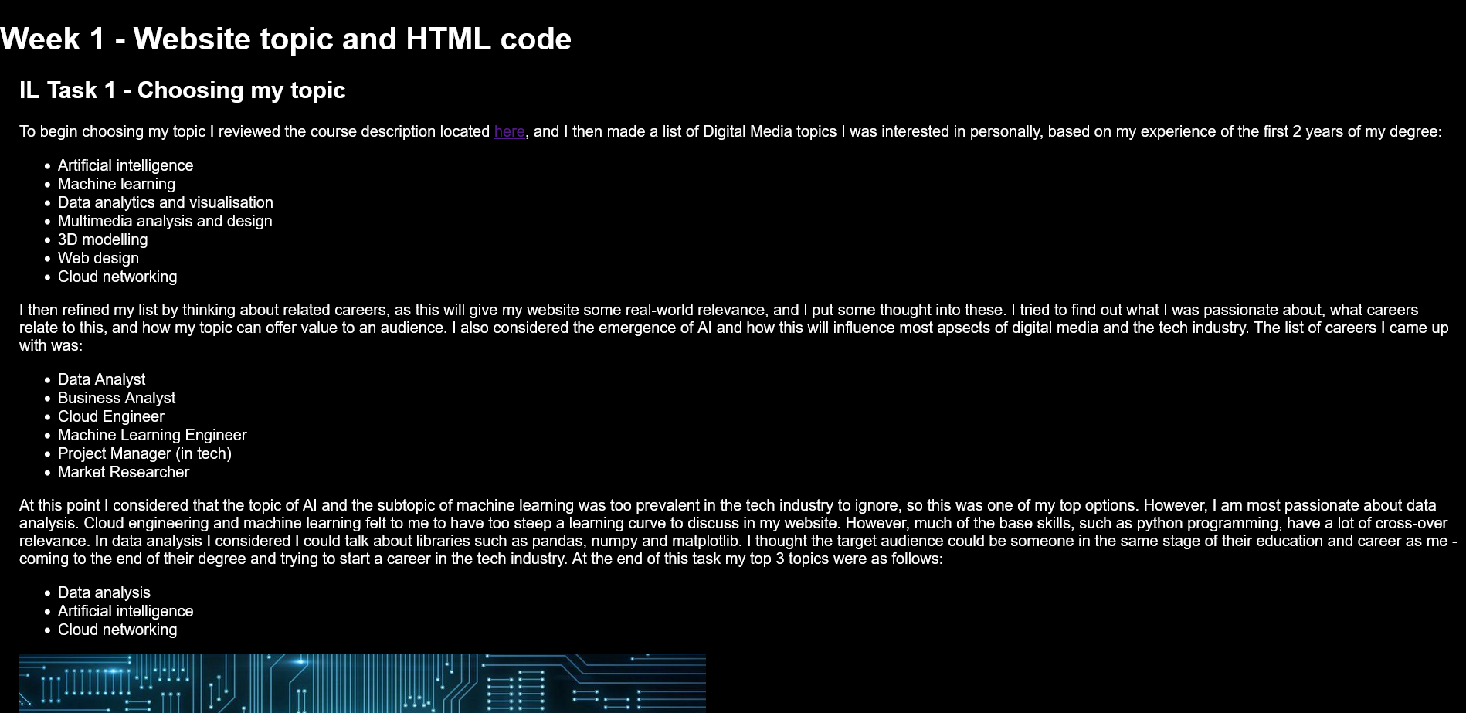

Figure 3. Section of a HTML webpage with minimal CSS applied - only background colour and font colour.

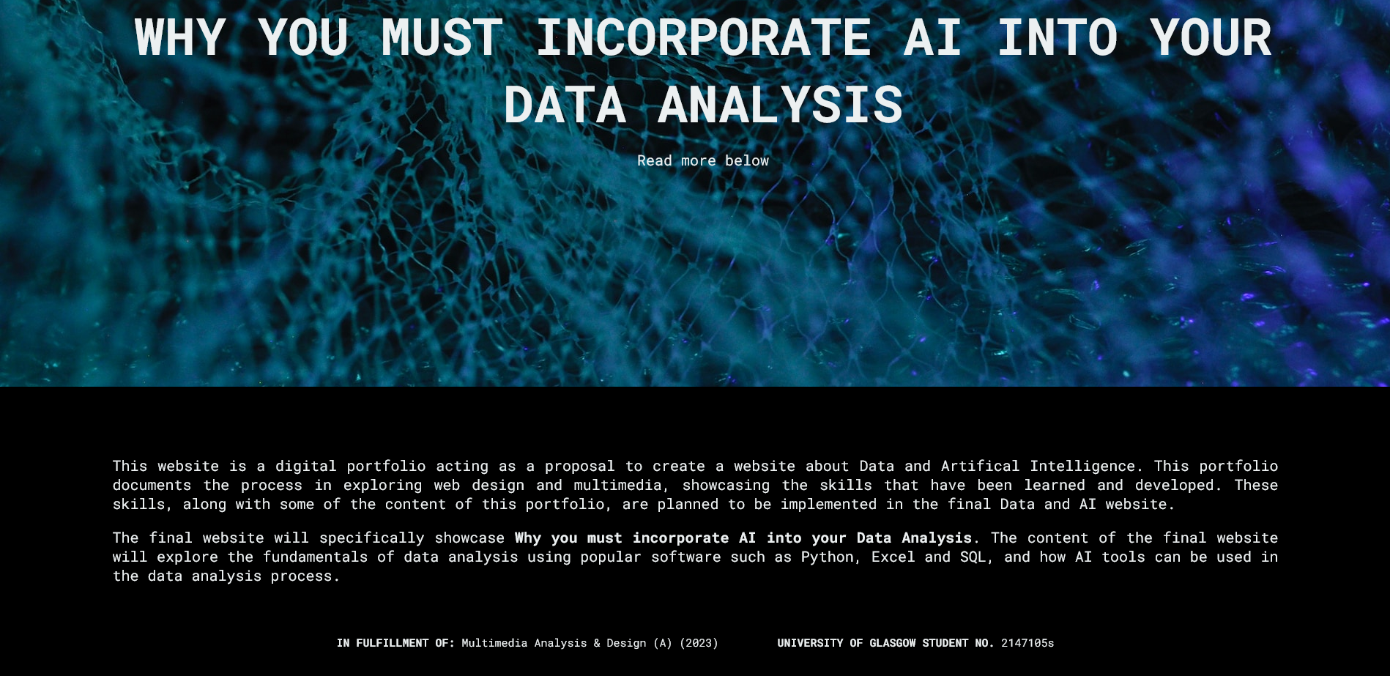

Figure 4. Section of a webpage utilising advanced CSS such as classes, padding, flexbox, background images, fonts, and colours.

After five weeks I had covered much of web design’s fundamental aspects and now began to analyse and edit multimedia. This was in order to experiment with ideas for the type of content on my final website. The types of media I investigated were text, images, audio, and video. I was already confident with these processes and utilised my previous experience to create various outputs that were optimised for the web in terms of naming conventions, comprehension, file size, and quality. As I want my final website to be at the cutting edge of technology, representative of the state of AI, I learned I want to prioritise media quality. This means that I will use high resolution tutorial images and video. I do not think I will use audio independently as I will need visuals to demonstrate data analysis and AI in action. I plan to keep text to a minimum and use an effective layout to break text into digestible sections for my audience.

Learning about accessibility standards and implementing them in my portfolio was one of the most exciting parts of my project. I had no experience in this area before, resulting in a process that was difficult but stimulating. My method involved reviewing current web accessibility standards from WebAIM to learn the most common and harmful effects, and then try to ensure my portfolio website was as inclusive and navigable as possible for users with disabilities.[6] This became important to me as I realised I wanted my final website to reach as large an audience as possible. While considering accessibility is time consuming and can alter your design in unexpected ways, I relished the challenge at making my design comply with these standards. One goal in particular was to mitigate the problem of using aria tags. *“5% of home pages had an ARIA menu (role="menu"), but 31% of ARIA menus introduced accessibility barriers due to the lack of necessary ARIA menu markup and interactions.”[7]* This means that if a user was operating a screen-reader, it would not identify where the menu is. This was a new problem that was confusing to me at first, but I found a source to help understand how to utilise span tags to add this required markup.[8] See figure 5.

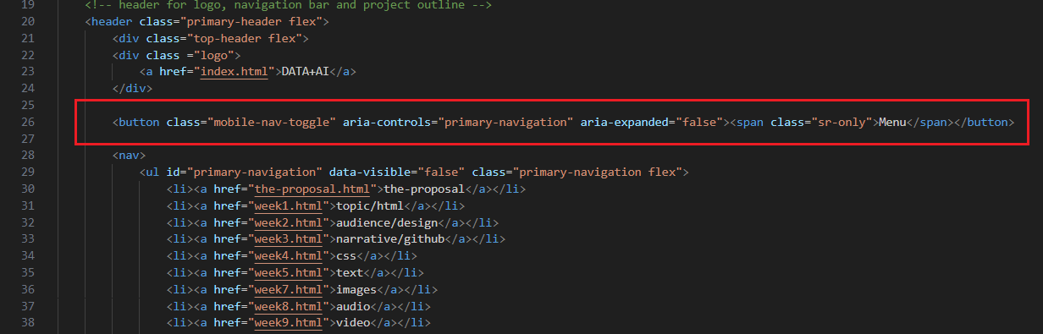

Figure 5. HTML code demonstrating use of aria and span tags to offer text for screen-readers only - see class="sr-only".

When reflecting on the accessibility of my portfolio I noticed many mistakes I had unfortunately made. Many sections of text are hard to read due to lack of a deliberate layout. The standard hyperlink colour does not contrast well against my black background. Many of my alt tags, which describe images when they fail to load, are not accurate enough. These last two mistakes are two of the most common accessibility errors.[9] In my final website I plan to use what I have learned to make a full Spanish translation available, improve my alt tags, improve the legibility of my hyperlinks, and update my webpage layout to enhance readability.

JavaScript is a programming language that allows for interactivity on the web. It creates, among other things, moving menus and animated buttons. Before this project, I only had a small amount of experience with JS when creating a website using a web framework last year. However, I know a variety of other programming languages so, similarly as with spoken languages, this provided me with some transferable knowledge. I did not spend much time on this part of my project because it is not graded, but I believe it to be important as ‘interactive elements’ are part of the course marking criteria and 98.8% of real websites use JS to make them more dynamic and increase engagement.[10] This motivated me to utilise basic JS in order to learn a distinctly practical and applicable skill. From analysing other websites, I noticed that JS is popular in menu/navigation (nav) bars and image slideshows, so I chose to focus my efforts there to offer the most efficient improvement against investment in my portfolio. You can see the results of the mobile nav bar in figure 6. In my final website I would like to utilise JS more. It is so prevalent I believe that web users expect JS as a base level of interactivity. Without it I think my website will seem unprofessional and static as opposed to a dynamic and enjoyable experience for my audience.

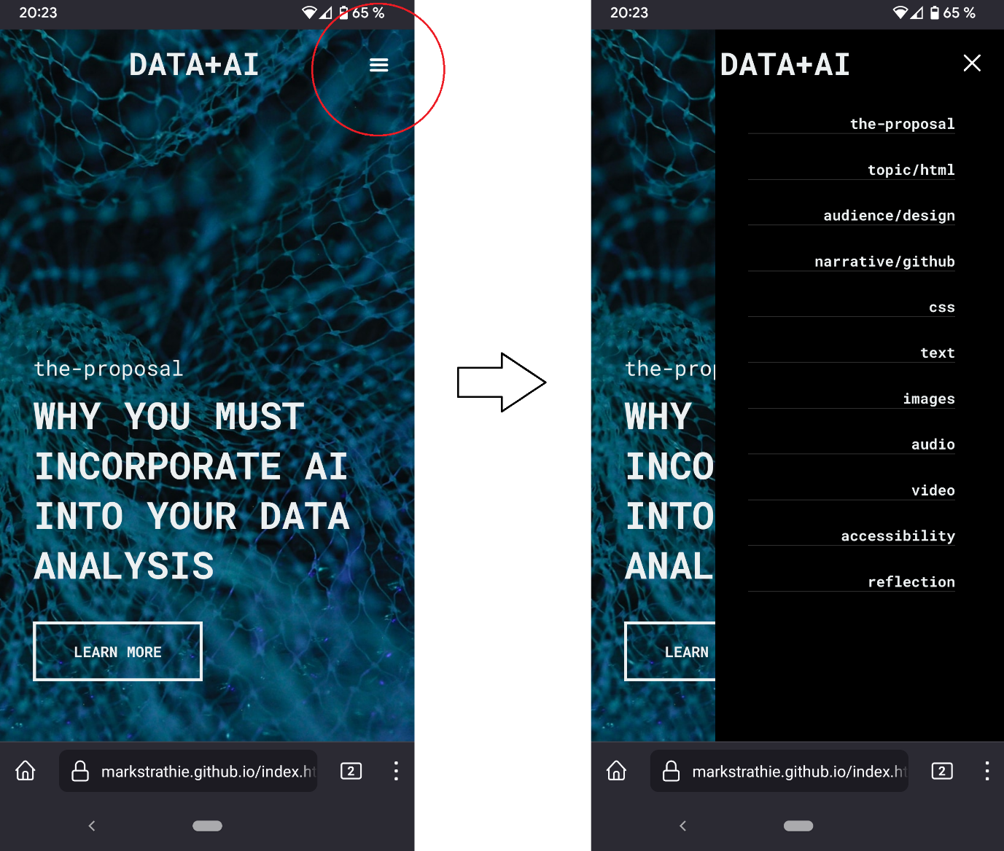

Figure 6. Demonstration of interactive nav bar on mobile version of portfolio website.

Overall, the process of creating my portfolio website was a challenging one that effectively reinforced experience I already possessed and additionally allowed me to develop many new abilities. The highlight for me was working on the topic, design, target audience, and narrative stages. Much of my skillset consisted of technical skills, so learning the softer skills of how to construct a plan, manage ideas over time, consider user needs, and clarify the goal of the project was exciting. However, during the project it became clear that nothing ever goes exactly to plan, and so I realised the importance of resilience and flexibility in all areas of work. While I enjoyed improving my soft skills most, I did learn some more technical skills – a vast amount of CSS to create responsive designs, how to improve accessibility on the web, and basic JavaScript functions.

On final reflection, I believe my portfolio project was fairly successful, mostly because of the reaction from my peers when they visit my website – they are initially excited to engage with it. The major pitfall of my project is having tunnel-vision when it comes to coding and being a perfectionist on small details. I feel like I could have utilised my time better by developing more in the areas of generating design concepts, audience needs, and focusing on user-interaction. I plan to implement these learning points next semester when developing the final website. Nevertheless, I am pleased to have had the opportunity to undertake such an enjoyable and challenging project, particularly one that produced such a tangible output – a fully functional portfolio website. It has ignited my passion for creating meaningful and impactful digital experiences in the future.

**Bibliography**

Davenport, Thomas H. and DJ Patil. “Data Scientist: The Sexiest Job of the 21st Century.*” Harvard Business Review.* https://hbr.org/2012/10/data-scientist-the-sexiest-job-of-the-21st-century (accessed Nov. 24, 2023).

Davenport, Thomas H. and DJ Patil. “Is Data Scientist Still the Sexiest Job of the 21st Century?*” Harvard Business Review.* https://hbr.org/2022/07/is-data-scientist-still-the-sexiest-job-of-the-21st-century?ab=at_art_art_1x4_s04 (accessed Nov. 24, 2023).

Hagendorff, Thilo and Katharina Wezel. “15 Challenges for AI: Or what AI (Currently) can’t do.” *AI & Society* 35, no. 2 (2020): 355-365. https://go.exlibris.link/PL0h7kjv.

Marr, Bernard. “Will ChatGPT Put Data Analysts Out Of Work?*” Forbes.* https://www.forbes.com/sites/bernardmarr/2023/02/07/will-chatgpt-put-data-analysts-out-of-work/?sh=5d9583ae4030 (accessed Nov. 24, 2023).

Powell, Kevin. “Learn flexbox the easy way.” *YouTube.* https://www.youtube.com/watch?v=u044iM9xsWU (accessed Nov. 23, 2023).

Powell, Kevin. “Responsive navbar tutorial using HTML CSS & JS.” *YouTube.* https://www.youtube.com/watch?v=HbBMp6yUXO0 (accessed Nov. 23, 2023).

Rogati, Monica. “The AI Hierarchy of Needs.*” HackerNoon.* https://hackernoon.com/the-ai-hierarchy-of-needs-18f111fcc007 (accessed Nov. 24, 2023).

Wang, Dakuo, Justin D. Weisz, Michael Muller, Parikshit Ram, Werner Geyer, Casey Dugan, Yla Tausczik, Horst Samulowitz, and Alexander Gray. “Human-AI Collaboration in Data Science: Exploring Data Scientists' Perceptions of Automated AI.” *Proc. ACM Hum.-Comput. Interact.* 3, CSCW, Article 211 (November 2019), 24 pages. https://doi-org.ezproxy.lib.gla.ac.uk/10.1145/3359313.

WebAIM. “The 2023 report on the accessibility of the top 1,000,000 home pages.” *The WebAIM Million*. https://webaim.org/projects/million/ (accessed Nov. 23, 2023).

W3Techs. “Usage statistics of JavaScript as client-side programming language on websites.” *W3Techs*. https://w3techs.com/technologies/details/cp-javascript (accessed Nov. 23, 2023).

1. Thomas Davenport and DJ Patil, “Data Scientist: The Sexiest Job of the 21st Century,” *Harvard Business Review*, https://hbr.org/2012/10/data-scientist-the-sexiest-job-of-the-21st-century (accessed Nov. 24, 2023).
2. Bernard Marr, “Will ChatGPT Put Data Analysts Out Of Work?” *Forbes*, https://www.forbes.com/sites/bernardmarr/2023/02/07/will-chatgpt-put-data-analysts-out-of-work/?sh=5d9583ae4030 (accessed Nov. 24, 2023).
3. Dakuo Wang *et al.*, “Human-AI Collaboration in Data Science: Exploring Data Scientists' Perceptions of Automated AI,” *Proc. ACM Hum.-Comput. Interact*, 3, CSCW, Article 211 (November 2019), 24 pages.

   Thilo Hagendorff and Katharina Wezel, “15 Challenges for AI: Or what AI (Currently) can’t do,” *AI & Society 35*, no. 2 (2020): 355-365.
4. Monica Rogati, “The AI Hierarchy of Needs,” *HackerNoon*, https://hackernoon.com/the-ai-hierarchy-of-needs-18f111fcc007 (accessed Nov. 24, 2023).
5. Powell, Kevin. “Learn flexbox the easy way.” *YouTube*. https://www.youtube.com/watch?v=u044iM9xsWU (accessed Nov. 23, 2023).

   Kevin Powell, “Responsive navbar tutorial using HTML CSS & JS,” *YouTube*, https://www.youtube.com/watch?v=HbBMp6yUXO0 (accessed Nov. 23, 2023).
6. WebAIM, “The 2023 report on the accessibility of the top 1,000,000 home pages,” *The WebAIM Million*, https://webaim.org/projects/million/ (accessed Nov. 23, 2023).
7. Ibid.
8. Powell, “Responsive navbar tutorial.”
9. WebAIM, “The 2023 report on the accessibility.”
10. W3Techs, “Usage statistics of JavaScript as client-side programming language on websites,” *W3Techs*, https://w3techs.com/technologies/details/cp-javascript (accessed Nov. 23, 2023).